
The Department of Electronics And Communication
Course Level Problem Based Learning

Course Title: DDHDL Verilog
Course Code:22ECE42
Semester: Fourth Semester

Project Report Titled
FPGA implementation of ECG signals using FIR filter

Submitted By
Sl No. | USN | Name
1 | 4SO24EC006 | AJAY KUMAR P
2 | 4S024EC018 | ASTEL JOSWIN RODRIGUES
3 | 4S024EC021 | BASHMA
4 | 4SO24EC022 | BRAHMI LAKSHMI U.H

Under the Guidance of
P.C Vijay Ganesh
(Assistant Professor, B.E, M. Tech, MIEEE)

PBL SECONDARY RESEARCH REPORT ON FPGA implementation of ECG signals using FIR filter
Chapter 1: INTRODUCTION:
Electrocardiogram (ECG) signal processing is a fundamental aspect of modern biomedical engineering, serving as a primary diagnostic tool for monitoring cardiac health. As wearable health technology and real-time patient monitoring systems become more prevalent, the need for high-speed, hardware-efficient signal processing architectures has increased. Implementing digital filters on Field Programmable Gate Arrays (FPGAs) provides a robust solution for these requirements, offering a balance between the flexibility of software and the high-speed performance of dedicated hardware
1.1 Background:
An ECG signal captures the electrical activity of the heart over time using electrodes placed on the skin. These signals are inherently low-frequency and low-amplitude, making them highly susceptible to various forms of noise and interference. To extract a clean signal for clinical analysis, digital filtering is essential. Finite Impulse Response (FIR) filters are widely preferred in medical applications because they are inherently stable and provide a linear phase response, which ensures that the different frequency components of the ECG signal are delayed by the same amount, preventing distortion of the P-QRS-T wave morphology.
1.2 Problem Statement:
software-based ECG processing (on PCs or microcontrollers) is common, it often lacks the throughput and parallel processing capabilities required for multi-channel, real-time monitoring in high-stakes environments. Traditional Digital Signal Processors (DSPs) may also struggle with power consumption constraints in portable medical devices. Noise in ECG signals can mask critical cardiac features, leading to misdiagnosis. There is a specific challenge in designing a filter that can effectively suppress wideband noise and power line interference without sacrificing the diagnostic integrity of the heartbeat's delicate peaks and intervals.
1.3 Objectives:
The primary goal of this project is to design and implement a high-performance FIR filter on an FPGA platform to enhance the quality of ECG signals. Filter Design & Simulation: To determine the optimal filter coefficients, leaf cells to achieve the desired frequencies for denoising ECG data. Hardware Description: To model the FIR filter architecture using VHDL or Verilog, focusing on efficient resource utilization (multipliers and adders). FPGA Implementation: To synthesize and implement the design on an FPGA board, utilizing its parallel processing capabilities to act as an accelerator for real-time signal filtration. Performance Evaluation: To validate the filtered output against the original noisy signal, ensuring high Signal-to-Noise Ratio (SNR) improvement and minimal signal distortion.

Chapter 2: Literature Review (Secondary Research)
2.1 Review of Existing Work:
1) As per the literature survey done by our team, we have an overview of top four research papers. Each study contributes a distinct methodological perspective, ranging from median filtering and Kaiser-windowed FIR design to Montgomery multiplier-accelerated adaptive filtering and Bessel-based lowpass filter synthesis.
In paper 1 published by Raykar and Bansod proposed a real-time ECG denoising architecture implemented on the Xilinx Spartan 3E FPGA using Verilog HDL. The system exploits the spike-removal technique borrowed from audio signal processing. The work demonstrates a significant reduction in median filter window size (91 versus 501 in the prior MATLAB-based work at 1000 samples/s), thereby reducing BRAM requirements and improving throughput. However, the authors do not report FPGA resource utilization metrics such as LUT count, flip-flip usage, or maximum clock frequency, which limits direct comparison with other architectures.
2) In paper 2 published by Uttraphan presented a comprehensive hardware implementation study of FIR filters for ECG signal denoising on the Intel Cyclone IV FPGA. Three distinct designs were implemented and compared. Design 1 uses direct hardware mapping with 21 parallel multipliers, achieving a maximum operating frequency of 50.66 MHz This design consumes 2,646 logic elements (42% of Cyclone IV resources) and dissipates 93.47 mW. Design 2 applies operation scheduling with a single multiplier controlled by an Arithmetic State Machine (ASM), reducing logic elements to just 145 (2% utilization) and power to 74.06 mW,). Design 3 uses three multipliers with concurrent computation, achieving 2,500 µs latency with 290 logic elements and 73.49 mW. The parallel and pipelined hardware architecture inherent to FPGA implementation is shown to decisively outperform software despite operating at a much lower clock frequency (50 MHz vs. 3.2 GHz), demonstrating the efficiency advantage of hardware parallelism.
3) In paper 2 published by Mulla and Kasetwar addressed the hardware implementation of an adaptive Least Mean Squares (LMS) FIR filter for ECG noise cancellation, with the key innovation of replacing the conventional multiplication unit with an efficient Radix-2 Montgomery multiplier.
The Montgomery multiplier architecture requires only 197 LUTs/slices—significantly fewer than prior implementations such as the Xilinx Vertex II linear systolic design (4,821 LUTs at 243.9 MHz). The system achieved a 22 dB SNR improvement from input to output across 10 test signal samples. The paper provides a compelling case for Montgomery multiplication as a hardware-efficient alternative in adaptive DSP systems, particularly where iterative weight updates demand high-throughput multiplication. Limitations include the restriction to 8-bit signals and only 2 filter taps, which may constrain the achievable noise rejection in complex ECG artifact scenarios requiring higher-order adaptive models
4) paper 4 describes the design and FPGA co-simulation of a Bessel Lowpass Digital FIR Filter targeting a 6 µs pulse wave for Medical Linear Accelerator (LINAC) applications. The device utilization summary shows 128 slice flip-flops (1%), 159 four-input LUTs (1%), 6 MULT18X18SIOs (30%), and 51 bonded IOBs (13%). The critical path delay (maximum clock delay) is 1.713 ns. Filter order selection was driven by comparison across orders 2, 6, 8, 10, and 15, with order 15 providing the best balance between pulse fidelity and implementation stability. While the application domain differs from ECG denoising, the underlying FIR filter architecture and co-simulation methodology are directly applicable to biomedical ECG processing pipelines.

2.2 Comparative Analysis Table

Paper | Method | FPGA Target | Key Metric | SNR/Speed | HDL Used
Raykar & Bansod (2015) | Dual Median Filter | Xilinx Spartan 3E | Window size 91+7 | SNR –10.33 dB | Verilog
Uttraphan et al. (2024) | FIR – Kaiser Window | Intel Cyclone IV | 21-tap, 50 MHz | 1,250× faster | Verilog
Mulla & Kasetwar (2014) | Montgomery LMS Adaptive | Xilinx XC3S500E | Radix-2, 113 MHz | SNR +22 dB | VHDL
ICNTE 2021 (Bessel FIR) | Bessel LPF order-15 | Xilinx Spartan 6A | Max delay 1.713 ns | N/A | VHDL

2.3 Research Gap Identification
Limited resource utilization reporting: most of papers didn’t report any FPGA resource utilization metrics (LUT count, flip-flop usage, maximum operating frequency, or power consumption). Without these figures, the design cannot be benchmarked against modern implementations or ported to contemporary FPGA families. Similarly, the ICNTE 2021 paper reports utilization for the Spartan 6A but does not characterize throughput in terms of samples per second or processing latency for a full ECG episode. Standardized reporting of at minimum Fmax, total logic elements, power dissipation, and throughput is required for fair comparative evaluation.

Absence of real time streaming validation: All reviewed implementations process pre-stored ECG records loaded from memory (MIT-BIH database files in ROM, or Physionet data). None demonstrates real-time streaming operation with live sensor data—i.e., acquisition from an analog front-end, ADC interface, streaming through the filter pipeline, and continuous output. Integration with an ADC interface (SPI or I2C protocol controller) and a real-time output display (UART to PC or LCD) is absent across all papers, leaving an important gap between laboratory demonstration and deployable clinical prototype.
Power consumption for wearable deployment: For the intended application of wearable or implantable ECG monitoring, where battery capacity is severely constrained, sub-milliwatt operation is desirable. None of the reviewed papers targets low-power FPGA families (e.g., Xilinx Artix-7 with dynamic power management, or Lattice iCE40 UltraPlus for ultra-low-power IoT applications), and none employs clock gating, operand isolation, or dynamic voltage-frequency scaling—established techniques for FPGA power reduction. This gap is particularly significant given the rapid growth of continuous ambulatory cardiac monitoring.

Chapter 3: Proposed System Design
3.1 Design Justification

1. What is the reason for selecting a 16-tap filter?
A 16-tap FIR filter is selected to achieve effective noise removal while maintaining reasonable hardware complexity. It provides a good balance between filtering performance and resource utilization in FPGA implementation.

2. What are the limitations of using fewer taps?
Using fewer taps reduces hardware usage but leads to poor filtering performance. It may not effectively remove noise and can distort important ECG signal features.

3.What are the drawbacks of using more taps than required?
Increasing the number of taps improves filtering accuracy but significantly increases hardware complexity, power consumption, and processing delay. This makes the design less efficient for real-time applications.

3.2 Block Diagram

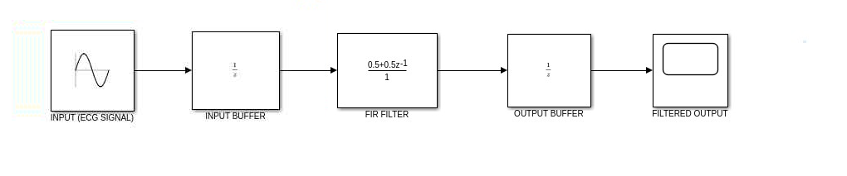

ECG Input
The ECG input provides the raw biomedical signal which may contain useful cardiac information along with noise and interference.

FIR Filter Core
The FIR filter core is the main processing unit of the system. It performs filtering by applying predefined coefficients to the input signal. The filter consists of delay elements, multipliers, and adders that together perform convolution to remove noise from the ECG signal.
Filtered ECG Output
The output of the system is the filtered ECG signal with reduced noise, making it suitable for further analysis and interpretation.

Input Buffer
The input buffer temporarily stores incoming sampled ECG signals before they are processed by the FIR filter. It helps in providing past and present input values required for convolution and ensures smooth data flow into the system.
Output Buffer
The output buffer holds the processed (filtered) ECG signal after computation. It stores the result before sending it to the next stage or display, ensuring proper timing and stable output transfer.
3.3 Architecture Diagram
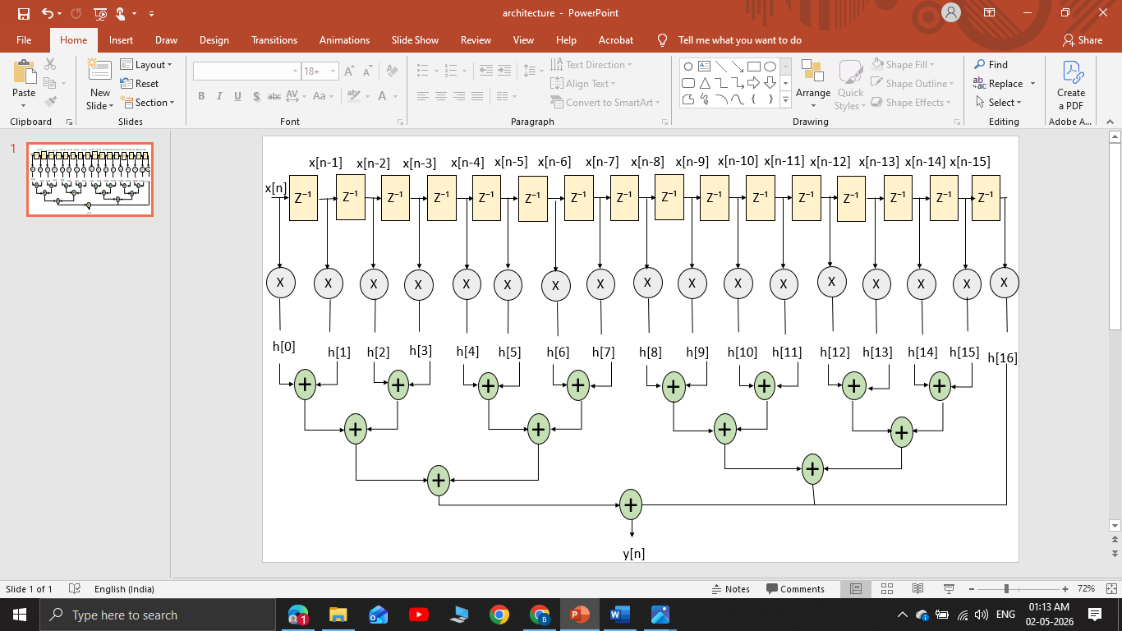
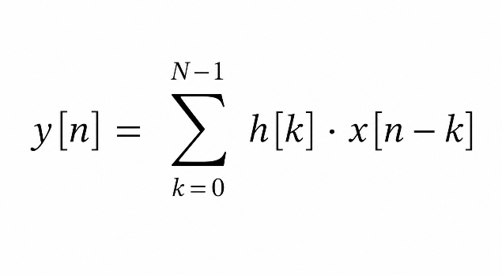 eq-1
y(n)=h(0)x(n)+h(1)x(n-1) +h(2)x(n-2) + h(3)x(n-3) +h(4)x(n-4) +h(5)x(n-5) + . . . . . . + h(15)x(n-15) eq-2
Delay Block
Each delay block stores the previous input sample. In a 16-tap FIR filter, there are 15 delay blocks. These create past versions of the input signal required for filtering.

Multipliers
Each input (current and delayed samples) is multiplied with a fixed coefficient. These coefficients define the filter characteristics (low-pass, band-pass, etc.). A 16-tap filter uses 16 multipliers.

Coefficients (h[n])
These are fixed values stored in the system. They decide how much weight each input sample contributes to the final output of the FIR filter.
Adders
The outputs of all multipliers are added together. A 16-tap FIR filter requires 15 adders to combine all multiplied values into one final result.
Chapter 4: Leaf Cell Design
4.1 Identification of Leaf Cells
- Adder
- Multiplier
- Delay

4.2 Leaf Cell Description
- Delay
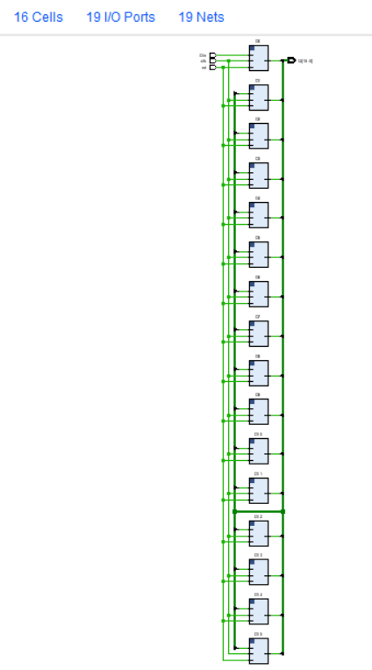

module shift_register_16_tb;
reg Din, clk, rst;
wire [15:0] Q;
shift_register_16 uut (Q, Din, clk, rst);
always #5 clk = ~clk;
initial
begin
$monitor("Time=%0t | Din=%b | Q(Binary)=%b",$time, Din, Q);
clk = 0; rst = 1; Din = 0; #10;
rst = 0;
Din = 1; #10;
Din = 1; #10;
Din = 0; #10;
Din = 0; #10;
Din = 0; #10;
Din = 0; #10;
$finish;
end
endmodule

- Optimization used
Shift register implementation to reduce control complexity
Register sharing to save hardware
Efficient clocking to reduce power consumption

- Multiplier

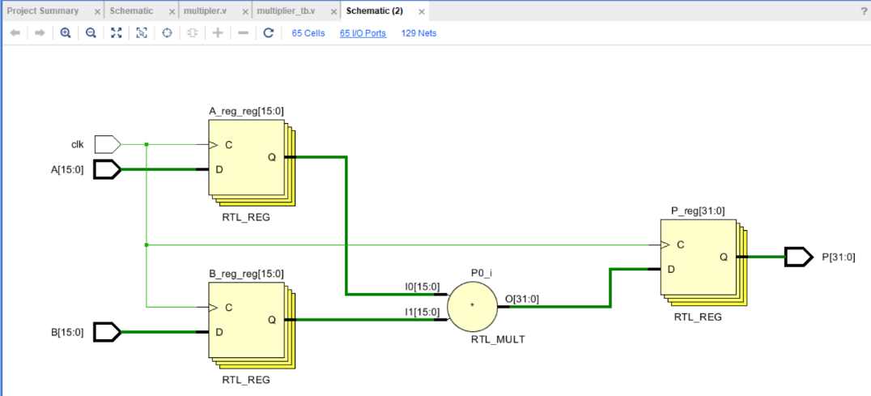
module shift_register_16_tb;
reg Din, clk, rst;
wire [15:0] Q;
shift_register_16 uut (Q, Din, clk, rst);
always #5 clk = ~clk;
initial
begin
$monitor("Time=%0t | Din=%b | Q(Binary)=%b",$time, Din, Q);
clk = 0; rst = 1; Din = 0; #10;
rst = 0;
Din = 1; #10;
Din = 1; #10;
Din = 0; #10;
Din = 0; #10;
Din = 0; #10;
Din = 0; #10;
$finish;
end
endmodule

Booth’s Algorithm to reduce number of partial products
(Booth’s Algorithm is a technique used in signed binary multiplication to make multiplication)
Use of pipelining to increase speed
Utilization of DSP blocks (in FPGA) for efficient multiplication

- Adder
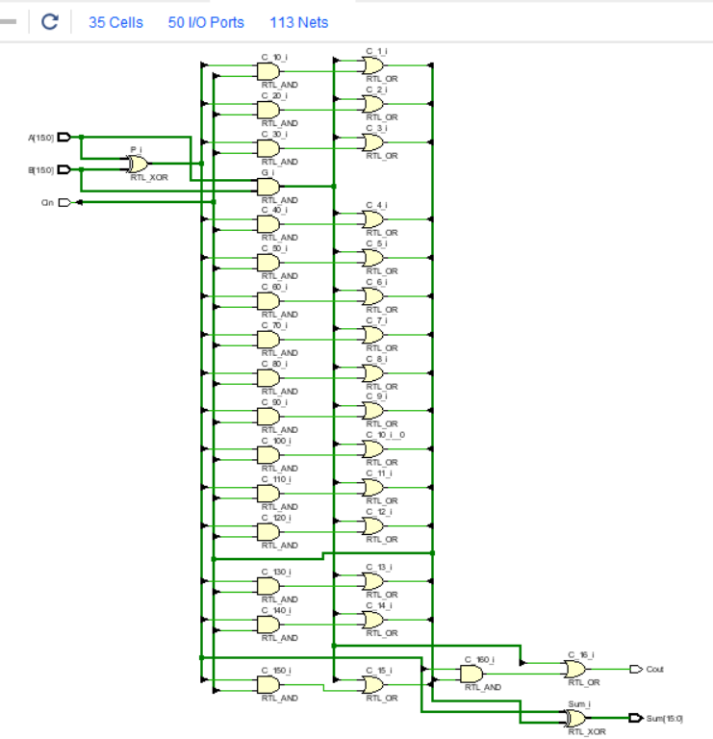

- Functionality
- reg [15:0] A;
- reg [15:0] B;
- reg Cin;
- wire [15:0] Sum;
- wire Carry;
- adder_16bit uut (
- .A(A),
- .B(B),
- .Cin(Cin),
- .Sum(Sum),
- .Carry(Carry)
- );
- initial
- begin
- $monitor("Time=%0t | A=%0d B=%0d Cin=%b | Sum=%b Carry=%b",
- $time, A, B, Cin, Sum, Carry);
- A = 1; B = 1; Cin = 0; #10;
- A = 2; B = 3; Cin = 0; #10;
- A = 4; B = 5; Cin = 0; #10;
- A = 6; B = 2; Cin = 0; #10;
- A = 7; B = 1; Cin = 1; #10;
- A = 8; B = 1; Cin = 0; #10;
- A = 9; B = 9; Cin = 0; #10;
- $finish;
- end
- endmodule

- Optimization used
4-bit Adder for faster operation
Reduced propagation delay
Bit-width optimization to minimize hardware usage

4.3 Leaf Cell Simulation

- Delay

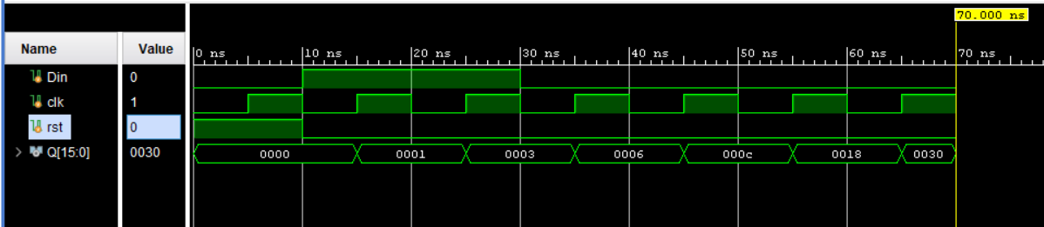

- Input test cases
The reset signal (rst = 1) clears the 16-bit shift register, making all output bits zero. After the reset is removed, the input Din is set to 1 for two clock cycles, so two 1s are inserted into the register. Later, Din is changed to 0, and with every clock pulse the stored bits shift one position to the left while 0 enters from the right side. Because of this shifting operation, the pair of 1s moves left across the register, producing the output sequence 0001, 0003, 0006, 000C, 0018, and 0030, which shows the operation of a 16-bit left shift register
- Output verification
Time (ns) | clk ↑ | Din | rst | Q[15:0] (Hex) | Q[15:0] (Binary)
0 | Reset | 0 | 1 | 0000 | 0000 0000 0000 0000
10 | ↑ | 1 | 0 | 0001 | 0000 0000 0000 0001
20 | ↑ | 1 | 0 | 0003 | 0000 0000 0000 0011
30 | ↑ | 0 | 0 | 0006 | 0000 0000 0000 0110
40 | ↑ | 0 | 0 | 000C | 0000 0000 0000 1100
50 | ↑ | 0 | 0 | 0018 | 0000 0000 0001 1000

- Multiplier

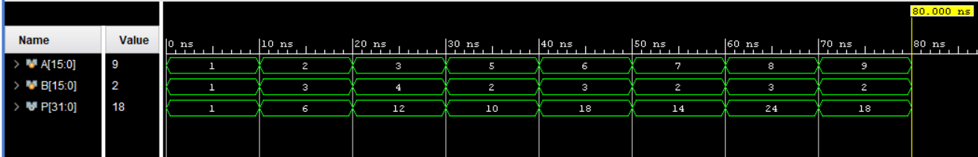

- Input test cases
The input test cases for the 16-bit multiplier circuit were applied by changing the values of inputs A and B at different time intervals. Initially, at time 0, both inputs were given as 1, producing an output product of 1. After every 10 time units, new input combinations were applied to verify the multiplication operation. The test cases included values such as A=2 and B=3 giving output 6, A=3 and B=4 giving output 12, A=5 and B=2 giving output 10, and so on. The inputs were provided in both decimal and 16-bit binary format, while the output product was observed in 32-bit binary format. These test cases help confirm that the multiplier correctly performs multiplication for different combinations of input values and produces the expected output product.

- Output verification

Time | A (Decimal) | B (Decimal) | P = A×B (Decimal)
0 | 1 | 1 | 1
10 | 2 | 3 | 6
20 | 3 | 4 | 12
30 | 5 | 2 | 10
40 | 6 | 3 | 18
50 | 7 | 2 | 14
60 | 8 | 3 | 24

- Adder
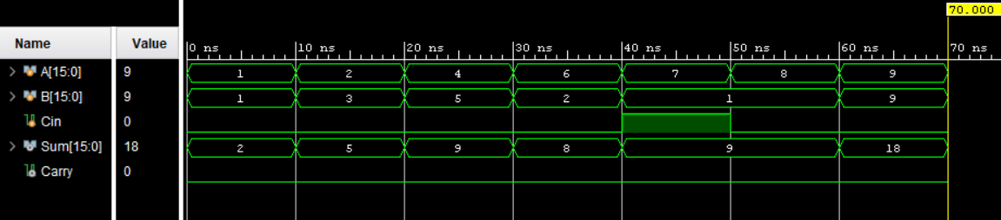

- Input test cases
The test cases for the 16-bit adder use small decimal inputs to verify basic addition functionality and carry behavior. Inputs range from simple values like (1, 1), (2, 3), (4, 5), and (6, 2) to slightly larger cases such as (7, 1 with Cin=1), (8, 1), and (9, 9), all chosen within 1 to 9 for easy understanding. Each test case applies different combinations of A, B, and Cin to check correct sum generation in binary form and to ensure proper carry output. These cases mainly verify normal addition situation where results remain within 16-bit limits, helping confirm correct operation of sum and carry logic in the adder design.

- Output verification

A (Decimal) | B (Decimal) | Cin | Sum (Decimal) | Carry | A (Decimal)
1 | 1 | 0 | 2 | 0 | 1
2 | 3 | 0 | 5 | 0 | 2
4 | 5 | 0 | 9 | 0 | 4
6 | 2 | 0 | 8 | 0 | 6
7 | 1 | 1 | 9 | 0 | 7
8 | 1 | 0 | 9 | 0 | 8
9 | 9 | 0 | 18 | 0 | 9

Appendix
● Simulation screenshots
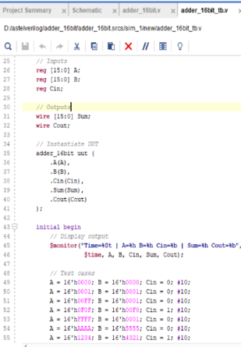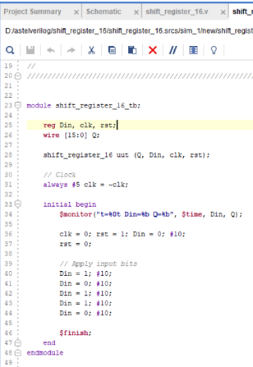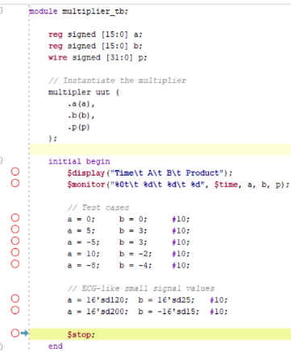

● Tool used
Vivado 2018.2
Simulink
power point

● References (IEEE format)
1) Journal of Advanced Research in Applied Sciences and Engineering Technology
Volume 40, Issue 2 (2024) 50-61
2) International Journal of Advanced Research in Electrical,
Electronics and Instrumentation Engineering
(An ISO 3297: 2007 Certified Organization)
Vol. 4, Issue 6, June 2015
3) FPGA Implementation of An Efficient Montgomery
Multiplier For Adaptive Filtering Application
4) FPGA Implementation of optimized FIR Filter For ECG denoising using Peres reversible logic gates.

